Review of Treasury Management Activity 2018/19

Introduction

The council’s treasury management activity is underpinned by the Chartered Institute of Public Finance and Accountancy’s Code of Practice on Treasury Management (“the Code”), which requires authorities to produce Prudential Indicators and a Treasury Management Strategy Statement on the financing and investment activity annually. The Code also recommends that members agree a treasury management report after the end of each financial year.

Investment and borrowing decisions are taken in light of long term borrowing requirements, the estimated level of reserves and actual and estimated cash-flow. This is in the context of the current and forecast economic condition. Consideration is also given to risks and compliance with Prudential Indicators. Therefore this report provides commentary on these factors for 2018/19:

- Economic environment
- Borrowing activity
- Investment activity
- Performance against the Prudential Indicators

Economic environment 2018/19

The UK economy has continued to show growth although this is below recent growth trends.

The continued uncertainty regarding the outcome of the discussions for the UK to leave the European Union have been impacting the economy. However, UK growth has also been affected by global factors. There continues to be uncertainty with the USA introducing protectionist policies which could lead to potential trade wars with both China and the European Union. The European Union has shown signs of a rapid slowdown in economic growth

Despite the low economic growth, employment data has remained positive with unemployment remaining low throughout the year. Labour market data for the three months to January 2019 showed the unemployment rate fell to a new low, 3.9% while the employment rate of 76.1% was the highest on record. The year also saw wages increasing.

Inflation as measured by the Consumer Prices Index (CPI) was 3.0% in April 2018. It fell steadily to below the Bank of England's target of 2% in both January and February 2019, with the latest figures showing Consumer Prices Index at 1.9%.

The continued uncertainty over the economy meant that the Bank of England has continued with its policy of slow and gradual increases in interest rates. Therefore the only change in the base rate came in August when the base rate was increased from 0.50% to 0.75%. Treasury management activity was undertaken with the expectation that interest rates would remain at the historically low levels but that there may be small increases. The latest forecast from Arlingclose, the council's treasury advisers, is for interest rates to remain at 0.75% for the foreseeable future.

Treasury Holdings 2018/19

In summary the holdings at the beginning and end of the year were as follows:

 | 31/3/2018 | 31/3/2019
 | £m | £m
Long term borrowing | 454.350 | 478.650
Short term borrowing | 495.571 | 556.196
Total borrowing | 949.921 | 1,034.846
Long term investments | 207.618 | 381.874
Short term investments | 113.079 | 97.427
Total investments | 320.697 | 479.301

Borrowing Activity 2018/19

The Code requires that the council, in the medium term, only borrows for capital purposes (with the underlying need to borrow for capital purposes being measured by the Capital Financing Requirement adjusted for premiums and debt relating to other authorities). Total borrowing in the year was managed within the operational and authorised borrowing limits as approved in the Treasury Management Strategy which reflects the underlying need to borrow for capital.

In previous years the council has pursued a policy of taking short term borrowing as short-term interest rates have been lower than long-term rates. This policy is reflected in the debt portfolio at the beginning of the year with there being a high level of short term borrowing. Consequently, the council had a significant requirement to replace existing short term borrow in year along with a requirement to fund new capital expenditure.

In general the policy of taking short term borrowing was continued during 2018/19. However, there is significant economic uncertainty and interest rates are at historically low levels. Therefore the benefits of short-term borrowing was monitored regularly against the potential for incurring additional costs by deferring borrowing into future years when long-term borrowing rates may rise. As Public Works Loan Board rates did fall during the year it was considered beneficial to take some longer term borrowing in the year to reduce the risk of potential future interest rate rises.

During the year the decision was also taken to repay the Lender Option Borrower Option Loan (LOBO). The table and graph below summarise the activity undertaken and the maturity profile of the debt at the year end.

Analysis of Borrowing Outstanding

 | Debt 31/03/2018 |  | Borrowing | Repayments | Debt 31/03/2019
 | £m | % | £m | £m | £m | %
Fixed Rate Funding
Public Works Loan Board | 213.100 | 22.4 | 30.000 | -7.500 | 235.600 | 22.8
Market Borrowing | 518.500 | 54.6 | 712.300 | -628.000 | 602.800 | 58.3
Total Fixed Rate Funding | 731.600 |  | 742.300 | -635.500 | 838.400
Variable Rate Funding
Public Works Loan Board | 125.750 | 13.2 | 0.000 | 0 | 125.750 | 12.1
LOBO * | 50.000 | 5.3 | 0.000 | -50.000 | 0.000 | 0.0
Shared Investment Scheme | 42.571 | 4.5 | 577.776 | -549.651 | 70.696 | 6.8
Total Variable Rate Funding | 218.321 |  | 577.776 | -599.651 | 196.446
Total Loan Debt | 949.921 | 100 | 1,320.076 | -1,235.151 | 1,034.846 | 100
*Lender option borrower option

Overall the average rate of interest paid in 2018/19 on the debt administered by the council was 2.10% per annum compared with an average rate of 2.07% in 2017/18.

The council did not enter into any new other long term liability arrangements in the year. The outstanding Private Finance Initiative liability at 31 March 2019 was £151.5m.

Investment Activity

The council invests its reserves and other cash balances. The total value of investments held (excluding fair value adjustment), at 31 March 2019 was £479.301m. This is £158.604m higher than at 31 March 2018. The table below shows the investment holdings and the movements during the year:

Maturity Range | Position at 31/3/2018 £m | 2018/19 Movement  £m | Position at 31/3/2019  £m
Call accounts and under 1 year | 113.078 | -15.651 | 97.427
Bank deposit 1-2 years | 0.000 | 1.300 | 1.300
Bank and local authority deposits 2-3 years | 1.300 | -1.300 | 0.000
Bank deposit 5 years + | 10.000 | 0.000 | 10.000
Local authority bonds | 35.624 | 52.699 | 88.323
UK Government and supranational bonds | 160.695 | 121.556 | 282.251

In undertaking investments consideration is given to the risk and liquidity within the portfolio which are affected by the maturity of the investment, asset type, country invested in and the credit rating. The position of the investment portfolio on these areas are reviewed as follows.

Investments by Maturity
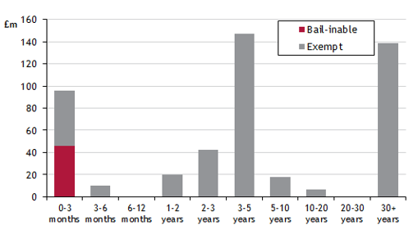

The graph shows the maturity dates of assets along with the exposure to bail-in in the event of a bank default (i.e. the risk that the investment may be lost or the principal repaid significantly reduced). As can be seen the exposure to bail in is relatively low and arises mainly in the short term with the use of call accounts. The very long term investments are principally investment in the UK government via Gilts.
Therefore the credit risk is low and the assets are saleable and do not have to be held to maturity thereby allowing the market risk to be managed.

Total investments analysed by asset type Total Investments analysed by Country

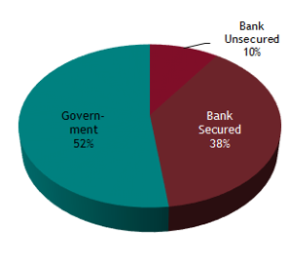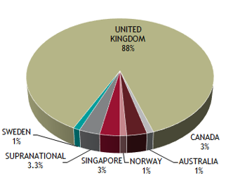

Total Investments analysed by credit rating

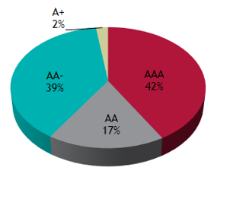
Security

Security of capital remained the council's main investment objective. This was maintained by following the council's Counterparty Policy, as set out in its Treasury Management Strategy Statement for 2018/19. This defined “high credit quality” organisations as those having a minimum long-term credit rating of A+. In practice the average credit rating in 2018/19 was higher at AA.

Investments with banks were held in call accounts only. Any longer term deposits have been restricted to deposits with other local authorities.
Liquidity Management

The council maintained a minimum level of primary liquidity through the use of Call Accounts. The council also has bond portfolios which are available for sale, at current market prices, if needed as “secondary” liquidity.

The council undertakes cash flow forecasting daily to determine the maximum period for which funds may prudently be committed.

Yield
The rates of return on the council's short-dated money market investments reflect prevailing market conditions and the council's objective of optimising returns commensurate with the principles of security and liquidity.

Overall the investment portfolios returned an average rate of 4.31% in 2018/19 which can be attributed to the categories as follows:

Maturity Range | Average Balance  £m | Average Rate
Call and under 1 year | 96.231 | 0.96%
Bank and local authority deposits 1-2 years | 1.300 | 0.88%
Bank & local authority deposits 5 years + | 10.000 | 2.95%
Local authority bonds | 40.796 | 4.08%
UK government & other bonds | 351.766 | 5.30%
Total | 500.093 | 4.31%

Impact of the Treasury Management Strategy on the council's revenue budget

In 2018/19 there was a net underspend of £27.568m against the financing charges budget, as shown in the following table. This underspend has arisen principally for two reasons namely: the implementation of the approved changes to the Minimum Revenue Provision (MRP) policy and the gain on the sale of investments. A changed MRP policy was approved by Cabinet in July 2018 which meant that the council had effectively made overpayments in MRP in previous years. These overpayments were used to reduce the charge in 2018/19.

Income received in the year was £16.792m higher than budgeted. With the markets responding to economic and political events there was volatility in the price of Gilts and other bonds. The increase in the price of Gilts enabled some to be sold resulting in a net gain of £13.7m. There have also been net gains of £2.6m resulting from sales on corporate bonds and on the traded bond portfolio. It is difficult to predict the movement in the markets and to assess the potential for gains therefore no provision for surplus on sale of assets was included in the 2018/19 budget.

Financing Charges 2018/19
 | Budget 2018/19 £m | Year End Position £m | Variance £m
Minimum Revenue Provision | 23.432 | 12.453 | -10.979
Interest Paid | 23.604 | 23.807 | 0.203
Interest Received/surplus on sale | -7.997 | -24.789 | -16.792
Total | 39.039 | 11.471 | -27.568

Treasury Management and Prudential Indicators 2018/19

The Local Government Act 2003 and supporting regulations require the council to have regard to the Prudential Code and to set prudential indicators to ensure the council's capital investment plans are affordable, prudent and sustainable. A comparison of the actual position at 31 March 2019 compared to the 2018/19 indicators set in the Treasury Management Strategy is set out below. All activity in the year complied with the Prudential Indicators and Treasury Management Policy Statement for the year.

Prudential Indicators
Authorised limit for external debt | 2018/19 | Actual
The authorised limit is a prudent estimate of debt which reflects the council's capital expenditure plans and allows sufficient headroom for unusual cash movements.
 | £m | £m
Borrowing | 1,150 | 1,035
Other long term liabilities (PFI schemes) | 175 | 152
TOTAL | 1,325 | 1,187

Operational boundary for external debt | 2018/19 | Actual
The operational boundary is a prudent estimate of debt but has no provision for unusual cash movements. It represents the estimated maximum external debt arising as a consequence of the council's current plans.
 | £m | £m
Borrowing | 1,100 | 1,035
Other long term liabilities (PFI schemes) | 155 | 152
TOTAL | 1,255 | 1,187

Capital Financing Requirement to Gross Debt | 2018/19 | Actual
 | £m | £m
Capital Financing Requirement | 907 | 918
Estimated gross debt | 1,003 | 1,035
Debt to Capital Financing Requirements | 111% | 113%

The Capital Financing requirement is the underlying need to borrow for capital purposes. This is the cumulative effect of past borrowing decisions and future plans. This is not the same as the actual borrowing on any one day, as day to day borrowing requirements incorporate the effect of cash flow movements relating to both capital and revenue expenditure and income.

Gross borrowing appears higher than the capital financing requirement because the shared investment scheme is accounted for as borrowing, but it does not form part of the capital financing requirement calculation. Adjustments are also required for premiums, long term debtors and transferred debt. The adjusted gross debt is slightly above the Capital Financing Requirement which represents borrowing in advance for capital and is allowable within the Code.

Treasury Management Indicators

Interest rate exposure | Upper Limit | Actual
The limit measures the council's exposure to the risk of interest rate movements. The one year impact indicator calculates the theoretical impact on the revenue account of an immediate 1% rise in all interest rates over the course of one financial year.
 | £m | £m
1 year impact of a 1% rise | 30 | 4.8
Maturity structure of debt  Limit on the maturity structure of debt helps control refinancing risk. | Upper Limit % | Actual %
Under 12 months | 75 | 54
12 months and within 2 years | 75 | 23
2 years and within 5 years | 75 | 3
5 years and within 10 years | 75 | 5
10 years and above | 75 | 15
Minimum Average Credit Rating | Benchmark | Actual
To control credit risk the council requires a very high credit rating from its treasury counterparties.
Average counterparty credit rating | A | AA

